**Introduction**

Python provides the Tkinter toolkit to develop GUI applications. It is upto the imagination or necessity of the developers, what they want to develop using this toolkit. This project is aimed to develop GUI of an application form (Registration form) to join a student’s association using Tkinter library. In this application the user will have to enter his/her personal details.

Tkinter is a standard GUI library for python. Python when combined with Tkinter provides a fast and easy way to create GUI applications. Tkinter provides a powerful object-oriented interface to the TK GUI toolkit.

Tkinter provides us with several features like buttons, labels and text boxes which makes it easier for the user to interact with the system. The button widget is used to display buttons in the applications. The canvas widget is used to draw shapes. And like that there are many more other widgets which help to add more features to the GUI and make it more convenient for the user to interact with the application.

Further using the openpyxl library and its functions the information can be stored in the excel sheet. **Openpyxl** is a Python library to read/write Excel 2010 xlsx/xlsm/xltx/xltm files. The openpyxl module allows Python program to read and modify Excel files. For example, user might have to go through thousands of rows and pick out few handful information to make small changes based on some criteria. Using Openpyxl module, these tasks can be done very efficiently and easily.

**Objectives**

Our system will provide the students an opportunity to apply themselves to join in any of the available student organisations in the campus. It will take the details of the applicant and all the data will be stored in an excel sheet, which can be further used by the recruiters of a student organisation.

The objectives of an application form to a club and the report prepared from it are to obtain information from the students that will shape the selection process, provide recruiters with the information they need to develop interview questions and confirm that you're able to do the job and that you understand the nature of the working relationship. It will also help the college management to know in which field students are interested in and what are the skills that they wish to develop and inculcate in themselves.

It will also help the students to know about the variety of available student organisations which will be a wonderful platform for them to grow all together as a community.

With the help of an application form you could receive the following information from the students when they apply to join in a student organisation.

Recruiters of a student organisation use applications to obtain basic information about who a student is, their preferred name, contact information, which academic year he/she is pursuing, registration number and which department or course the student is from.

One of the key questions on an application is whether you can perform the essential functions with an enthusiasm and willingness.

**Screen shots**

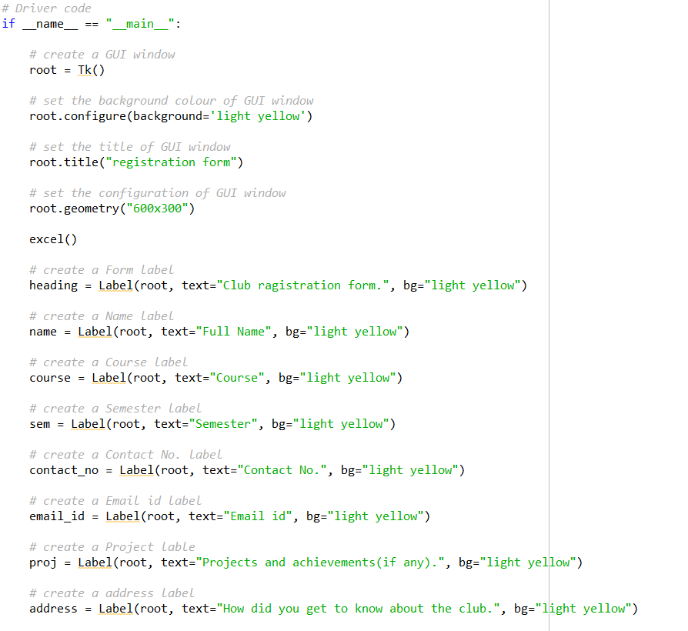

Here using the functions of the TKinter library a GUI for the club registration form is generated.



As the user hits the submit button the information of the student gets saved in an excel sheet as shown above.

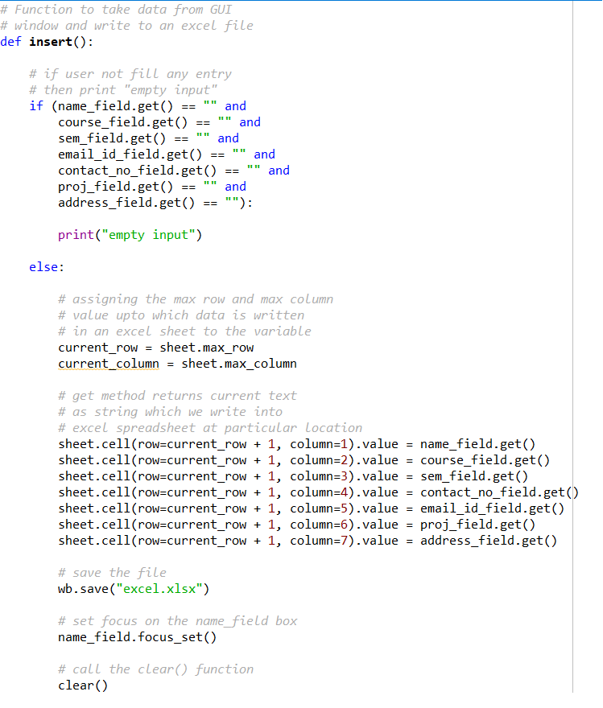

The above function saves the entered values in the specified columns in the excel sheet.

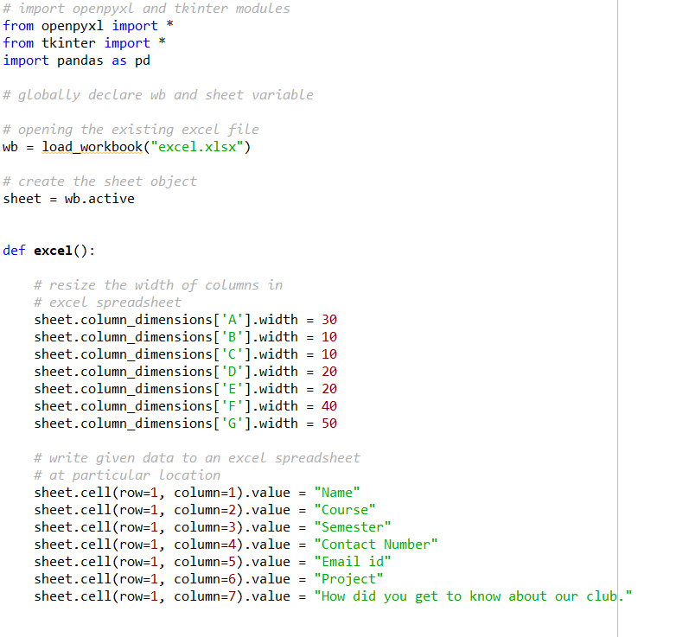

The above function opens the excel sheet and formats the table to the information of the user.

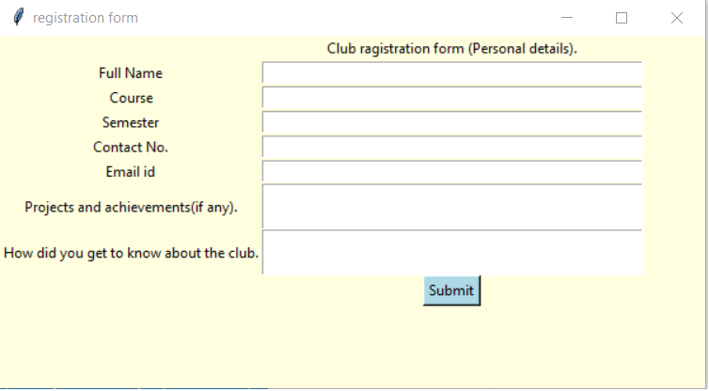

This is how the registration form appears to the user.

**Bibliography**

**Websites:**

Geeksforgeeks.com

openpyxl.readthedocs.io

docs.python.org

[en.wikipedia.org](https://www.google.co.in/url?sa=t&rct=j&q=&esrc=s&source=web&cd=8&ved=2ahUKEwj3-KPIs-nlAhWZaCsKHcygA5kQFjAHegQICRAB&url=https%3A%2F%2Fen.wikipedia.org%2Fwiki%2FTkinter&usg=AOvVaw30PZmkt3RG6Gy4X614KomN)

**Books:**

Liang Y. D. - Introduction to Programming Using Python – 2013